Contents
ASC Reports 3
Channel Islands Area 3
Chiltern & Thames Valley Area 3
Cornwall Area 4
Devon Area 4
Dorset Area 5
East & Central Lancashire Area 7
East Midlands Area 8
Essex Area 8
Farsi Speaking Area 8
Free Counties Area 9
Greater Manchester Area 10
Hampshire Area 10
Highlands and Islands Area 10
Kent Area 12
Merseyside Area 12
Norfolk & Suffolk Area 14
North East England Area 15
North East London Area 15
North West London Area 16
NW England and N Wales Area 16
Scotland - East Coast Area 17
Scotland - Edinburgh & Lothians Area 17
Scotland - West Coast Area 18
Scotland – West Lothians 18
The Shires Area 18
South East London Area 19
South Wales Area 20
South West London Area 21
Surrey Area 21
Sussex Area 22
West Country Area 23
West Midlands Area 23
Yorkshire & Humberside Area 25
Sub Committees Reports 26
Regional Delegate 26
UKCNA – Convention Committee 27
UKFD - Fellowship Development 29
UKH&I - Hospitals & Institutions 30
UKPI – Public Information 31
UKSO – Service Office 32
UKW&H Website & Helpline 34
Ad Hoc – Inventory 36
Ad Hoc – visionUKSO 37
Concept 10 AD HOC 39

ASC Reports

Channel Islands Area
RCM report
ASC: Jersey – Channel Islands

ASC meeting details:
Day and time:  First Thursday of every month | Venue:  The Clubhouse | ASC mailing address:  The Clubhouse  La Rue Funchal  St Helier
Number of groups and meetings:
ASC comprises 4 voting GSRs with each meeting being represented
4 meetings per week
Tuesday @ 6pm Just For Today (attended by the local Rehab facility)
Wednesday @ 6pm Step & Tradition
Friday @ 6pm Newcomers – recently changed room at current venue to one with heating!
Saturday @ 6pm Speaker & Topics

Sub-committee activities:
PI – presentation took place – greatly supported by ‘Will’ from UKPI – delivered ‘Myths & Realities’ of NA (James) and had a man share of experience, strength and hope (Rachel) – audience of about 30 delegates (all women) who work with disadvantaged and socially excluded single parents some of whom have addition problems themselves or their partners do – very emotive couple of hours – left literature and contact numbers – received an email with excellent feedback and gratitude expressed
Please list H&I meetings:
Events:
None planned
Current financial status and contributions:
Treasury report submitted – GBP 205 balance – below GBP 250 prudent reserve

Summary for presentation at Region:
Responses to action points from RSC:
None
Questions for Region:
For UKH&I – new Governor at HMP La Moye – our newly-formed sub-committee would be grateful for contact and guidance and know how on approaching HMPO/Governor to take NA to prison
Are prison officers present in meetings from people’s experience who do this service work?

Chiltern & Thames Valley Area
No Report Received

Cornwall Area
No Report Received

Devon Area
RCM report
ASC:
Devon
ASC meeting details:
Day and time:  25th November 2018  2.00pm – 4.00pm | Venue:  EDP Drug & Alcohol Service, 81 Heavitree Road, Exeter, EX1 2LX | ASC mailing address:  StayingClean1@outlook.com
Number of groups and meetings:
20 meetings
Sub-committee activities:
Currently we have an active H&I/PI combined sub-committee. The focus is on Exeter Prison, Channings wood Prison and the recovery facilities in Plymouth.
The committee gave a H&I presentation at Shekinah Mission to residents and have had a request to do something similar in Oakhampton and the new detox unit at Longreach (Plymouth).
Please list H&I meetings:
The H&I committee meet bi-monthly before the ASC at the same venue as the ASC. Next meeting 27th January 2019 at 12.30pm.

Please can H&I chair receive minutes from H&I committee directly to gfeatherstone2@gmail.com and a point of contact in the PI committee?

Do H&I and PI reimburse costs to members attending committee meetings?

Events:
The only event currently planned is a Devon Unity Day in Plymouth, October 2019.
The ASC is in consulting with GSR’s regarding holding some learning days around the roles and responsibilities of group service positions and drawing up a GSR welcome pack.
A decision will be made regarding the 2019 Devon campout at the January ASC.
Additional information:
Devon ASC has been fully active and functioning for several years now. Members are now more comfortable in the service roles and are looking to sponsor in new members when roles rotate in March 2019. We still have some key vacancies at the ASC, so members are doubling up on service. We usually have around 50% of GSR’s present to vote at the ASC.
We have experienced two incidents of misappropriation of funds on the Area, one at Group level and one at Area level. In both situations the NAWS guidelines #30 have been followed and guidance sought. The voting and details around both the incidents have been clearly minuted and there has been full transparency around both processes. The incident at Group level has been dealt with (in accordance with #30 by the member, the group and their sponsor), with the involvement of ASC. The member, with the support of their sponsor, has regularly attended ASC to share their process of amends. The incident at Area level could not be resolved and is now in the process of going to small claims court (in accordance with #30).
With regards to the sad loss of the life of a member’s child at the 2017 Devon Campout, this matter is still under investigation. Our members have recently provided computer and phone records to aid the police process. Our current understanding is that NA are not under investigation regarding this matter.

Current financial status and contributions:
Bank balance = £4357.30
Petty Cash balance = £397.89 plus £140 Cheque
Total: £4895.19(minus £2930 ring-fenced for Knapp house, £780 prudent reserve) = 1185.19 (available)

A discussion was held regarding donations to region. This was postponed until January 2019 ASC as the area is in the process of reviewing the budgets for service committees and there are events such as learning days which the meetings are requesting. Any funds left over after the financial review will be sent to Region.

Devon Summary for presentation at Region:
Responses to action points from RSC:
None as only new into role.
Questions for Region:
Do any Areas have experience of holding Home Group Learning days? The aim being to support members with learning more about the roles and responsibilities involved in running healthy groups which are focused on their primary purpose. This is something that has been requested by Devon members.

Dorset Area
ASC: Dorset
ASC meeting details: |  | Address: | Day and time:
Venue: | Beaufort road community centre | 158 Beaufort road Southbourne  Bournemouth BH65LB | 3rd Sunday of the Month 5pm
Number of groups and meetings:
47 meetings in Dorset
15 GSR present at last area
Sub-committee activities
Dorset PI
Contact has been established with Mental Health Unit in Dorchester and a presentation is to be arranged and given in January 2019.

We are liaising with H&I (Hospital & Institutions) with a view to giving presentations to staff where H&I take meetings. NA posters have also been given to H&I so they can place them where appropriate and permitted.

Our mail shot of posters is now done around 300 in all.

We are also producing flyers on how to get involved with PI which are given out at Dorset Meetings.

We continue to contact organisations (e.g. homeless shelters/Police/Hospitals) and are awaiting responses.

Dorset H&I

Continue to carry in message in institutions

11 meetings into 4 treatment centres and 1 prison YOI Portland
A new meeting has been agreed with Guys marsh, but again we need someone with prison clearance or it won’t happen.
- The Verne is open but not yet ready for meetings
Events:
Festival of Recovery (Dorset Campout)
Dates and venue can now be confirmed as Burn bake Campsite, Corfe Castle on Wednesday 29th May 12:00 noon – Sunday 2nd June 2019. 11:00am.
This avoids clashing with Hampshire's convention and coincides with half-term
Fund raising events have started, Successful New Year’s Eve dance and up and coming speaker jams and other events
Additional information:
Following 18 months of discussion, motions, voting and writing, the Dorset area guidelines Ad hoc committee have nearly completed their work on the new guidelines for this area, these will be finished and printed by February 2019
Discussion around how we can encourage more GSR’s to attend area, ideas were GSR work shop, Building stronger home group work shop,
We welcome any experience from region and other areas.
Current financial status and contributions:
No Contribution this region
closing Balance £1,562.88
Prudent reserve £3,000
below prudent reserve by 1,437.12

Narcotics Anonymous Dorset treasury report. 04/01/2019

To UK region.
I am writing to ask if you would consider returning £668.42 to our area, which is the amount our convention committee forgot pay UKSO and we ended up writing a cheque on their behalf as they had disbanded for the year, I understand this is a highly unusual request.
It was a clerical error made by myself as I didn’t make proper note of this cheque when working out our region donation as I was rushed into sorting it out Friday night prior to the ASC.
Our prudent reserve is £3000.00
Our current balance is £1762.88
Our area is propped up by fund raising and being a costal area most of our money is raised in summer. We have just introduced new guidelines for our treasury which will help for future years.
We are well into our prudent reserve now and we are not expecting any large moneys returned until the campout in May/June if it’s a success.

Dorset Summary for presentation at Region:
Responses to action points from RSC:
No responses
Questions for Region:
Dorset area donated £2000 to Region in November 2018
This was a mistake by our treasurer and he never took in to account a bill we owed UK SO of £668.42
We are asking Region if we can be given back £668.42 from the £2000 as this was an error and we are struggling financially and below our prudent reserve.

East & Central Lancashire Area
RCM report
ASC: East and Central Lancashire Area

ASC meeting details: |  | Mailing address: | Day and time:
Venue: | Woodnook Baptist Church  Royds Street, BB2 2JH |  | Wednesday 6th February 2019@ 7.30 pm
Number of groups and meetings:42

Sub-committee activities:
Local services last Friday of the month at 6.30 pm at Woodnock Baptist Church
Awaiting confirmation of next Convention committee meeting

Current financial status and contributions:
closing balance £545.47, this is £204.53 below prudent reserve.

Summary for presentation at Region:
Responses to action points from RSC:
What would be the added cost of using Brussels? What impact do these options have on UKNA? What would the cost implications be? How would we recruit if the office was moved? Would Brexit have an impact on using Brussels?
Re key rings, we recycle things that we throw away, do we throw away key rings?
Questions for Region:
none

East Midlands Area
RCM report
ASC: EAST MIDLANDS AREA

ASC meeting details: |  | Address: | Day and time:
Venue: | St osmunds church. | London road, derby DE24 8UW | Saturday 5th January 12pm
Number of groups and meetings:
18 active groups. 14 GSR’s present at area meeting. 26 meetings in area.
Sub-committee activities:
HI subcommittee details:

HMP Dovegate - monthly-good attendance & the lads on the wing are now facilitating own
meetings.
HMP Nottingham - fortnightly meetings – good attendance
HMP Foston Hall – Zoe will be starting meeting on a monthly basis due to start 22/2/19 can GSR’s
let females know H&I could do with their service for this to be successful.
HMP Lowdham Grange – Public Information didn’t manage to make contact. H&I decided to take
control PLO said he will try to make contact.
7
Edwin House – Fortnightly meetings, everything going OK.
Finances
Closing Balance £600.00
H&I believe that it’s our responsibility to look after our own finances. It would be an extra
commitment on our committee to attend ASC for funds. We value our autonomy & it’s working fine
as it is.
PI subcommittee details:
No report because there was no meeting in December.
Events:
Unity Day 28th December 2018 - 12pm - 11pm
St Andrews URC, Chaucher Street, Nottingham, NG1 4FG
The day went really well and over 150 people. Attended from many areas. We took £1134.07 which
was deposited to the ASC account this week. Thank you to ASC for your support setting up the
Unity Day.
Additional information:
Both the Chair and Treasurer positions have now been fulfilled and the members are standing in ADHOC until someone presents themselves to take on the service.
Current financial status and contributions:
Closing Balance: £2596.00

Summary for presentation at Region:
Responses to action points from RSC:
Questions for Region:
Proposal to invite members to hold an ASC Learning day, as well as carry out an inventory of how
we are operating. To seek confirmation from West Midlands about their availability. - To try and get
contact details to arrange.
We are having problems with the email address used by our area. Some members do not receive emails at all, the secretary has tried to resolve this by checking the junk or spam folder and checking that there are no automatic rules set up for the emails from emasc@ukna.org. This is an ongoing problem that is affecting several GSR’s and other members. We have received an email from region and have replied, still waiting for another response?
Our treasure has requested is there some sort of acknowledging action when we send money to regional? Only as we have sent money up in the past, we have never received an acknowledgment or receipt. What’s the process of this?

Essex Area
RCM report
ASC:
Essex Area Service Committee
ASC meeting details: |  | Mailing address: | Day and time:
Venue: | Trinity Methodist Church  481 Clay Hill Road Basildon SS16 4NN |  | Last Wednesday of each month
Number of groups and meetings:
31
Sub-committee activities:
H&I
Our H and I committee have had some problems in the past with inappropriate behaviour. In both Passmores House and HMP Chelmsford. Both meeting were terminated.
But there is a new committee forming and they are positive about the future.
They are working on getting back into HMP Chelmsford. And we have managed to re-establish a meeting in Passmores House Treatment centre. But one NA member is banned from attending.
H and I are looking at approaching other facilities within the Essex Area.

PI
There is a new PI committee which is planning a panel event inviting professionals such as probation, Social workers, police.

PI met with probation to discuss Chit cards which was a positive meeting. But the chit card situation will be on going as they don’t think that anonymous signature on a card is substantial enough to meet their needs.

H&I Meeting
Passmores House treatment facility.
Please list H&I meetings:
Events:
Convention
Essex is having its first two-day Convention ate the Park Inn Hotel Southend on Se
This will be a great event please come it’s the 31st August to the 1st September 2019.
Please see flyer for information
Additional information:
Issues in the Essex Area
The main problem is GSR attendance at the ASC we are trying to encourage members to take this role seriously. We have a constant concern about quorum as technically there should be over 50% of GSR’s in attendance to vote. But obviously we can’t operate like this, so we have voted to act as quorate when we have 6 GSR’s attending. If this situation continues, we may have to downsize.
Current financial status and contributions:
Finance
£3082-78 closing balance at the last ASC this includes ring fenced money of £1500 for our convention.
We are in the process of setting up a direct debit with Region for £50.00 mandate at the moment this will will be reviewed.

Summary for presentation at Region:
Responses to action points from RSC
none
Questions for Region:
- Have chit cards worked in other areas with probation?
- We are currently setting up a pay pal account for our convention. Pay pal said that if we could give information about our non-profit status that whey would give a discount. Is this information available.
- Motion:
“ That the UKSO board of directors provide a full report of the scope, the pros and cons of charitable status
And present to the fellowship as a whole before any decision making about charitable status takes place.”

Intent
To Give the fellowship clear understanding and implications of this important issue.

Farsi Speaking Area

Farsi Groups ASC, RCM Report to Region Jan 2019
Number of meetings in ASC: 13 Groups. 10 in London, 1 in Manchester, 1 in Birmingham and 1 in Leeds. The ASC meeting takes place from 6.00 to 9.0 pm on the first Wednesday of each month, in Swiss Cottage Community Centre, London NW3 3NT. All NA members are welcome to attend.
Details of all Farsi speaking meetings in the UK are available online, from the UKNA website.
There are currently 20 Farsi speaking meetings in the UK as listed on UKNA website.
A new chair and a new Tea Person were elected during the meeting.
Vacancies: Chair of F&E Committee, Chair of H&I and Chair of Website and Mtg Addresses

Subcommittee activities:

PI/H&I/phone lines:
Men: 07931 399310, Women: 07482542835
It was agreed that the above committee will now be split up into 3 committees as follows:
- Public Information (PI) – Already has a committee and chair
- Hospitals and Institutions (H&I) – requires new chair
- Web site and Meeting Addresses – requires new chair
However, before chairs can be elected the guidelines need to be updated to include these posts.

Literature: This committee has an increased total budget of £4,000.0. and continues to provide Farsi literature to all Farsi speaking groups in the UK and Europe.

F&E: Nothing to report

Workshops: Workshops will now be held once a month in rotation, at meeting venues, either before, or after the recovery meetings. This has already started and so far workshops have been successfully conducted in group venues on topics such as, Recovery and Service and maintaining an atmosphere of recovery in meetings. One workshop has been held in Birmingham and another one is due shortly in Manchester.
Treasury Report: Due to the added cost of placing a new ad in another weekly magazine the prudent reserve has been increased.
Prudent Reserve: £700.0 Contribution to Region: £89.23
Prev. balance from Dec 2018: £582.85
Total group contributions for Jan 2018: £355.88
Gross Total: £918.73
Costs: rent @ £37.50 + Tea/Coffee @ £12.0 + workshops @ £100.00.
Total costs: £149.50
Balance = £769.23 Less Prudent Reserve @£700.0 = £69.23
Donation to Region: £89.23
Final balance less prudent reserve = -£20

Questions for Region: -

RCM: Rahman Alterante RCM: Baz

Free Counties Area
No Report Received

Greater Manchester Area
RCM report
ASC: Greater Manchester report for Dec 2018

ASC meeting details:
Day and time:  Second Thursday of month 7.30pm | Venue:  St. Luke's church longsight | ASC mailing address:
Number of groups and meetings:
63 meetings 61 groups
Sub-committee activities:
P I 13 presentations planned for new year with the Dwp already done over a dozen.
H &I Styal women’s prison. Forrest Bank men’s prison. Smithfield and Chapman Barker detox units.
Please list H&I meetings:
Additional information:
Area has decided to buy a laptop for area. For treasurer literature and secretary.
Current financial status and contributions: £2000+ Donation to region.
Opening balance. £5000 ring fenced for convention
£2000 lit money. £1000 asc. Total £8000
Closing balance £5000 for convention. £1141.73 lit. £1344.71 asc of which £344.71 for a laptop.
Total £7141.7

GMASC Summary for presentation at Region:
Responses to action points from RSC:
No Response
Questions for Region:
No Response

Hampshire Area
No Report Received

Highlands and Islands Area
HIGNA Area Service Committee Region Report January 2019
RCM report
ASC: HIGNA Area Service Committee
ASC meeting details:
Day and time:  Last Sunday of every even month at 5pm | Venue:  Bluejeans room ID https://bluejeans.com/176732843 | ASC mailing address:  meetings@higna.org.uk
Website: www.higna.org.uk
Number of groups and meetings: 7 Meetings per week

Sunday: 7pm JFT T/D. Venue https://bluejeans.com/754367039
Monday: 1pm JFT T/D. Venue, https://bluejeans.com/770876670
Tuesday: 7pm Ask it Basket. Venue, https://bluejeans.com/452423020
Wednesday: 1pm Step. Venue, https://bluejeans.com/108569655
Thursday: 6:30pm In times of Illness. Venue, https://bluejeans.com/401351412
Friday: 7pm Speaker. Venue, https://bluejeans.com/437955547
Saturday: Living Clean T/D. Venue, https://bluejeans.com/438737301

All the above meetings are well supported with an attendance of between 15 to 25 members.

Sub-committee activities: We currently have no standing sub-committees and address specific service needs on an ad hoc basis as and when they arise by drawing on the experience of group members as required.
Please list H&I meetings: 0
Events: Past and Upcoming Events:
Xmas Marathon which was a collaborative online service effort with the NA at Home group and ran for 36 hours. Average attendance per hourly meeting slot was around 10-15 with up to 25/30 in some meetings. Members attended from 21 countries across 5 continents.
New Year’s Marathon which was also a collaborative online service effort with the NA at Home NA group and ran for 36 hours. Average attendance per hourly meeting slot was around 10-15 with up to 25/30 in some meetings. Members attended from 22 countries across 5 continents.
Online Convention: We are currently considering the logistics of putting together a similar collaborative service effort to create the first ever Online NA convention hopefully sometime in the next 12 to 18 months and will keep Region informed as to our progress or not with that possibility.
Additional information:
Since we and the NA at Home group of meetings moved venue platforms to Bluejeans in November of 2018, after 7 years of using Skype, we have, and despite the early concerns being expressed by our members about the change, had an increase in meeting attendance. Due in part to the simplicity and adaptability of the Bluejeans cross device application and it not requiring members to register for an account to attend meetings. That simplicity is also making it easier for members to do service at the meetings and we anticipate an increase in the number of meetings in the coming year as a result. In the two months from November and between the two groups we have run 288 meetings, attracted over 4290 endpoint meeting entries from 433 cities in 50 countries across 5 continents. The access to such anonymous data is, we hope, going to inform any future PI efforts we might make to increase awareness of the Online Meetings Community into those areas of the fellowship who are unable, for whatever reason, to attend face 2 face meetings. As an Area we are able to reach addicts in and outside of the UK, in treatment centres, isolated places, hospitals, etc who may need or want to hear our message of recovery. HIGNA currently has members doing meeting service from across the UK the US and Italy.
Attendance at Region:
As a non-geographical area our physical attendance my not always be possible as we draw our trusted servants from the group’s global membership. It is therefore our hope that Region will be willing to embrace the use of the technology at hand to enable us to fully participate in the service of representing our member’s conscience and fully contribute to all other areas of Region business.

Current financial status and contributions:
Our Tradition 7 funds are held in two separate locations, 1) The Group Bank Account which is set up with multiple signatories and 2) A club or society PayPal account which being linked to the bank account also has multiple access by T/S’s. Contributions can be made by direct deposit to the bank or via the PayPal portal embedded in the group website. All accounts are managed by our Group Treasurer and we registered with the HMRC as a Club or Society in 2018. To comply with HMRC regulations we have been asked to submit our group accounts in April of this year for inspection which we have been informed is normal procedure for new accounts of this type but that it is highly unlikely that we will attract any payable tax due to the low level of income and nature of the group. We were also informed by HMRC that under UK tax law we had done absolutely the right thing to register.

Current Balance (As of the date of this report):
PayPal: £883.05 (includes Refund from Skype of £477.42)
Bank Act: £386.52
Balance: £1269.57 (Please note that this current total balance is the accumulation of several years of contributions)

Current Annual Expenditure:
Website + Domain etc: £49.00
Bluejeans account: £158.25 (= Cost/rent equivalent per meeting of £0.43p per week)
Total expenditure: £207.25

Prudent Reserve: £500.00 (2 years expenditure allowing for inflation exchange rates etc )
Future projects: £500.00 (To be determined)
Surplus Balance: £269.57

Donation to Region: £100.00?
Closing balance: £1169.57

Summary for presentation at Region:
This is a significant moment in the history and growth of Narcotics Anonymous as we take our seat at Region today as the first group of Online meetings anywhere in the world and in the true spirit of the unity of Tradition 1 be made welcome as an Area. We of the Highlands and Islands Online group of meetings wish to thank you for welcoming us with open arms and look forward to the future as we continue to grow, have the opportunity to carry our members conscience and hopefully become a valued member and asset to the UKNA Region.
Responses to action points from RSC:
At this time and as a new Area with no time to discuss them fully we have no group conscience to issues previously raised at Region.
Questions for Region: A severely disabled member is wishing to start an online LGBT meeting and is asking for support from the LGBT recovery community to do that so please can we ask that RCM’s take that back to their Areas and ask anyone who may be willing to help with setting up and doing service to such a meeting to please contact us at meetings@higna.org.uk

Kent Area
No Report Received

Merseyside Area
ASC meeting details:
Day and time: Every 3rd Saturday of each month at 1.00pm. | Venue: Stoneycroft United Reformed Church 95 green lane old Swan Liverpool L13 7EB | ASC mailing address:
Number of groups and meetings: 41

Sub-committee activities:
Reports from panel leaders regarding HMP Liverpool: Meetings are taken place in the prison visiting room up-to 5-6 members attending. The prison as asked for members to be vetted however, this has not taken place. Need members with one – year clean time to go in and carry the message. All members will provide all relevant details one week before. Kevin White Unit: meetings usually well attended people engaging and asking questions. The message is being carried and H&I have good relations with staff. Literature at present is available there. Birchwood detox centre: average attendance around 6 people. Strong message being carried people informed of meetings in area upon release. Good relations with staff. Plenty of Literature at Venue but we run low on white booklets.
HMP Altcourse: The meetings are well attended although there are problems with meetings starting late. Attendance 5-10 however 30 people attended the meeting last week. Literature needed for meeting. A lot of the members that attend live in Wales and have asked for a meetings list for that Area. (Committee suggested lists can be downloaded from Northwest website.)
PI/PR Report (Will) On the 28th November 2018 a presentation was given at the governors meeting we also spoke to 50-60 staff. Presentation was received openly and much discussions took place about our future involvement and our working partnerships with the prison, prisoners and staff.
On the 20th November a gold fish bowl meeting was presented to Rose Brae Hostel. We received a lot of useful feedback and have good rapport with staff and residents. We are waiting on dates to present gold fish meetings to Wirral Ways to Recovery and Phoenix House.
We have been asked to do a family stand at HMP Liverpool on 18th December 2018. We have also been asked to do a gold fish bowl meeting at Fairfield however we don’t have human resources to cover this invitation. We have asked members to come forward to support us in this service provision of Narcotics Anonymous. We are sending out new meetings list and invite presentation letter to local services. Website is up-to date input and feedback welcomed by our members to progress us forward in our efforts.
Events:
A group funded unity-day took place over the Christmas period. Free food and access to a play area for children was made available. Newcomers were present there and the message was carried by strong members who shared their experiences of their time in NA.
Additional information:
MANA Area is under-represented there is not enough people attending area. The affect is two-fold we can’t effectively carry out NA business without having the votes to do so. Money is being held back by groups this is resulting in not enough money to cover the budgets for H/I & P/I literature. Action taken to encourage more people to attend Area and get a feel of what it is about. To ask GSR to feed back to groups about the flow of funds and why it is important to not sit on money and send it up the line. The big question we have asked GSR to ask groups if we still want MANA to continue and would it make a different if times were changed or the day. We will know in the next coming weeks if Mana will be able to sustain itself or make the decision to close itself.

Current financial status and contributions:
Opening Balance £6,185.19
+ Donations: £135.00
+ Literature: £480.45
+ Outgoings: £69.95
Closing Balance: £6,730.69
Prudent Reserve: £1,140
Ring-fenced convention money: £5,000

MASC Summary for presentation at Region:
Responses to action points from RSC:
none
Questions for Region:
How can area encourage members to get involved with service at this level and remain focused on their own recovery?

Norfolk & Suffolk Area
ASC meeting details: |  | Mailing address: | Day and time:
Venue: | Friends Meeting House  Upper Goat Lane, Norwich |  | 1st Wednesday of month, 19.00
Number of groups and meetings: 31 meetings.

Sub-committee activities: Our H&I and PI activities are organised by our Local Services Subcommittee. We have H&I meetings in Warren Hill, Hollesley Bay, and Highpoint prisons. We are in contact with staff from Wayland Prison and Norwich prison, but have had administrative difficulties in organising meetings there. We have H&I meetings in Hebron House female treatment centre.
We regularly do presentations to the local drug treatment providers.

Events: One of our meetings had a Christmas Quiz night which was well attended.
Our F&E subcommittee is in flux at moment, so will have more information next time about future events.
Additional information: We are an active and thriving area.

Current financial status and contributions: We have a prudent reserve of £500 which we are £100 over. We were going to donate this to the RSC but decided instead to buy literature for our H&I meetings. Maybe next time.

Summary for presentation at Region:
Responses to action points from RSC:
We thought the UKSO Vision point 2, ‘new location, with meeting space for UK Subcommittees, etc. was best option for our UKSO.
We have annotated a couple of the draft guidelines, especially the Whatsapp which has some grammatical errors.
We think Keyrings should be made from recycled and non-toxic plastic.
Questions for Region:
What is the cleantime requirement for prison sponsors?

North East England Area
ASC meeting details:
Day and time:  Last Saturday of Every Month | Venue:  George Street Social  45-51 George Street  Newcastle upon Tyne  NE4 7JN | ASC mailing address:  Carlos R  rcm@northeast.ukna.org
Number of groups and meetings:
26

Sub-committee activities:
HMP Durham - Positive feedback meetings are going well
HMP Lowe Newton - 2 females have clearance currently, however, this will be down to 1 for four months.
HMP Holme House - A Member is trying to start things in motion and will be contacting the facility.
Events:
GSR’s have been asked to get feedback groups GSR's have been asked to get feedback from groups concerning whether the next NENA convention should be a 2 or 3-day event.
Current financial status and contributions:
Cash in bank £3536.69
Cash in hand £60.21
Donations from GSR's £130
Expenses £94.50
Balances include-
Monies transferred by convention committee £2724.80
The ring-fence of £1900 voted for 2019 convention.
£200 cheque is with Mark S to donate to the region

Summary for presentation at Region:
Responses to action points from RSC:
Questions for Region:
Questions for Area as follows:
The ASC is looking for guidance on policy set-up (template of an existing one preferably)
Guidance on Convention Committees
Guidance on setting a prudent reserve

North East London Area
No Report Received

North West London Area
RCM report NW London ASC
ASC: Thursday 6 January

ASC meeting details: |  | Mailing Address: | Day and time:
Venue: | Westbourne Grove Church  Westbourne Grove Corner of Ledbury Road  London  W2 |  | Thursday 6 January  19.30 Hours
Number of groups and meetings: 25

Sub-committee activities:
P & I very active doing various presentations active and healthy.
H& I cut donation from area from £250 a month to £160 a month.
All meetings in institutions being covered, with more people volunteering each month.
No London Convention representative again third month.
NO F& E but active donation from New Year event
Please list H&I meetings:
Current financial status and contributions:
Donation £891.59 Leaving prudent reserve of £1,500.

Summary for presentation at Region:
Responses to action points from RSC:
None
Questions for Region:
None

NW England and N Wales Area
NWENW – report to RSC – January 2019
RCM report
ASC: First Saturday of every Month 1:00pm, Saturday, December 1, 2018 - 13:00, Fairfield Community Centre, Fairfield Street, Warrington, Cheshire, WA1 3AJ
ASC meeting details: |  | Mailing address: | Day and time:
Venue: | Fairfield Community Centre  Fairfield Street, Warrington, Cheshire, WA1 3AJ |  | First Saturday of every Month 1:00pm, Saturday, December 1, 2018 - 13:00,
Number of groups and meetings: 32

Sub-committee activities:
H & I - Sunday, December 2, 2018 - 15:00 Venue to be arranged due to change will be confirmed.

Events:
GSRs agreed to reach out to other groups to encourage more GSRs attend. Will be having an informal unity hour before the next ASC - food and a service presentation / share 2nd February.
New year event in Warrington went well - approx £1000 funds raised
Current financial status and contributions: No contribution this time as just moved to new account.

Summary for presentation at Region:
Responses to action points from RSC:
Questions for Region:

Q. our H and I committee have been set a form from bank requesting tax numbers and info that we may need help filling in. Have any other areas had this or similar letters? Is it best to just ask the bank for help?

North West and North Wales Area Proposal to Host Region in Preston on 11-12th May 2019

Venue
Cotton Court Business, Church Street, Preston PR1 3BY
Room £180 per day plus vat = £216 x 2 = £432
Seats up to 60 and free WIFI and parking at the venue.
Refreshments
£40 + vat for hot water and paper cups and get hot water provided etc. and we buy our own tea and coffee sugar milk etc.
Hotel
Holiday Inn – Preston
Free WIFI
Friday £70 Saturday £70 for twin / double or £70 single includes full Lancashire breakfast.
Disabilities - lifts to all rooms however no walk-in showers.
Approximately 5-minute walk to venue which will be about £3.50 in a taxi.
Parking
NCP Car Park £4 next to hotel
Travel - Hotel is literally next door to Prestons (award winning) Bus Station – 5-minute walk from Preston railway station which is situated on the West Coast Mane Line Railway (£3.50 in a taxi).
In luxurious Preston town centre so plenty of pie shops[bakeries] selling pasties, sandwiches, salads and a Sainsbury's for those who like cous cous for dinner[lunch] and restaurants and take away for your tea[dinner].
{Words in [ ] translation for none northern people}

Scotland - East Coast Area
No Report Received

Scotland - Edinburgh & Lothians Area
RCM report
ASC: Edinburgh and Lothians

ASC meeting details:
Day and time:  First Sunday 1.30pm | Venue:  St Andrew’s Church, Easter Road, Leith | ASC mailing address:
Number of groups and meetings: 19
Sub-committee activities:
H&I: many positions available in H&I. Saughton Women’s Prison: 3 women have signed up for Prison/Distance Sponsorship, and one has heard back so far. Chair of Edinburgh and Lothians H&I to contact UK H&I about attending the UKH&I meeting.
PI: various meetings and presentations have happened this month, and more are planned.
Convention: report given.
Please list H&I meetings:
Events:
Edinburgh and Lothians Convention 9th and 10th February – come and support us! All are welcome!
Additional information:
Some lunchtime groups very short of group members. Friday lunchtime meeting will now officially close. Vice-chair plus another member to attend and find out how best we can support.
The women’s meeting has closed.
Current financial status and contributions:
No contribution.

Prudent reserve £500.
Closing balance: [RCM didn’t write down, will have this info for Saturday morning of Region].

Summary for presentation at Region:
Our Treasurer has contacted UK Treasurer for support but at the time of our ASC (afternoon of Sunday 6th) had not heard back.
Responses to action points from RSC:
none
Questions for Region:
Please can you share experience on how to deal with members (whose primary fellowship is not NA) being asked to do main shares in meetings? This is now happening in NA meetings in Edinburgh and Lothians and we would like support on how best to manage it.

Scotland - West Coast Area
No Report Received

Scotland – West Lothians
No Report Received

The Shires Area
RCM report
ASC: The Shires Area
ASC meeting details: |  | Address: | Day and time:
Venue: | Buckden Millennium Community Centre | Burberry Road, Buckden, St Neots PE19 5UY | 1300-1500 3rd Saturday of the month
Number of groups and meetings:
27 groups spread out over 25 meetings with 3 more opening this month in Kettering, Bedford, Milton Keynes ( will join the Shires )
Sub-committee activities:
Events:
Sunday May 6th NA cup
Current financial status and contributions:
Opening Balance £1329.51
Donations in £290.00
Outgoings £651.58
Closing Balance: £967.83 (£147.83 above prudent reserve)
Donation of 200 Pounds to Region

Summary for presentation at Region:
not sure if we are reading the questions or have a proper summary?
Responses to action points from RSC:
Questions for Region:
Two Questions:
1: Does the region have insurance that new groups can use or is it up to the ASC or group Individually
2: we are starting an ASC level H&I Sub Committee but are unsure how to proceed correctly

South East London Area
ASC:
South East London
ASC meeting details: |  | Address: | Day and time:
Venue: | Deptford Church |  | November 28 2018  January 02 2019
Number of groups and meetings: 35 groups 20 GSR & 15 GSRs respectively
Positions available: Vice chair, vice treasurer, Literature secretary, vice literature sec., vice minutes secretary
Sub-committee activities:
H&I
Brook Drive Detox Unit: Coordinator: Barney. Meeting going well Literature well stocked. .
HMP Bronzefield: Coordinator:
No report.
HMP Brixton. Coordinator: needs a new coordinator.
No report
- HMP Wandsworth Coordinator: Nick
No meeting as no secretaries.
HMP Highdown

Meeting held with Brixton prison to discuss why it’s so hard for NA members to pass security checks – highlights include:
- DVD information on NA requested by prison
- NA members failing to disclose all convictions leading to problems with recruiting potential prison meeting secretaries – looking into security clearance and different types of vetting process, perhaps using StandardPlus clearance. Arrests not relevant, only convictions.
- Maybe possible to hold meetings in a less secure area of the prison
- Prison is concerned about potential security risks
- There is a time allocation for member to come into the prison – between 5pm and 7pm we may have as many meetings as we want
Service positions available: SW Rep, V Treasurer, V chair, Prison Liaisons, Minutes Secretary
PI – No report
Nacho- No report
London Convention – No report
Xmas dinner – No official report yet but it went very well
Events:
Service Learning Day planned for May between the four London Areas. Venue: Montgomery Hall, Oval, London.
Aim: Learning through fun workshops. All areas of London coming together and working better.
Possibly H&I and PI to present and talk around their roles.
Looking at the option to form a Metro Service Committee and will involve all areas of London. Emphases on outreach, attraction to service etc. Nice food and speakers.
London Convention 19 -21 April
Current financial status and contributions:
Closing Balance - including reserve £3,405.67- excluding reserve £1,068.67. No contribution this time.

Responses to action points from RSC: No response to finding premises for potential UKSO move.

South Wales Area
ASC meeting details: |  |  | Address: |  |  | Day and time:
Venue: |  | Quaker mtg Hse, Annex, Swansea |  | Pagefield House, Swansea SA14EZ | Lastt ASC Nov 25th 18
Venue: | Cyswllt Contact |  | 25 North Parade  Aberystwyth  Dyfed  SY23 2JN |  |  | Next ASC Jan 27th 18
Number of Group Meetings and GSRs in attendance at area: Total Meetings 15 GSRs attending 6
Swansea 3 GSRs 5 Meetings
Abergavenny 0 GSRs 2 meetings
Newport 0 GSRs 1 meeting
Blackwood 1 GSR 1 meeting
Cardiff 2 GSRs 2 meetings
Aberystwyth 0 GSRs 3 Meetings
Lampeter 0 GSRs 1 Meeting

Sub-committee activities:
H&I:
HMP Parc (Bridgend) –fortnightly Running well
Cardiff Prison – Still Have clearance problems cannot get reply from G4S Rep
Pentwyn Probation - Still Have clearance problems cannot get reply from G4S Rep
HMP Swansea – Fortnightly Meetings over Last 4 Months – going Well
HMP Usk – Still Have clearance problems cannot get reply from G4S Rep
Events:
The Xmas Party in Swansea went well, although failed to make a profit
South Wales are planning a campout event for the coming Summer.
South Wales wish to plan an Area convention and request any help and advice possible from more established Areas holding regular conventions.
Additional information: December Area in Aberystwyth was postponed till January
Current financial status and contributions:
And that our Prudent reserve should be raised to £600. However, suggestions have been made to ringfence a small sum toward the future campout and convention events this year. This prudent reserve amount will be reviewed and reduced at the next Area, should the ringfencing occur.

Responses to action points from RSC:
Questions for Region:
Welsh White Keyrings have been requested but are unlikely to be provided due to low production amounts. Would it be ok to print such keyrings with a 3d printer and bring them to UKNA to be verified legitimate? All profits above production costs would be given to UKNA or in the case that UKSO should have to provide them. Could we supply them to UKSO at cost?

South West London Area
No Report Received

Surrey Area
RCM report
ASC: Surrey

ASC meeting details: |  | Address: | Day and time:
Venue: | St Peters Church Hall | Church Street,  Woking  Surrey GU22 9JE | 3rd Saturday of the Month  14:00 – 15:30
Number of groups and meetings:
Out of the 27 meetings in Surrey, 20 now report into this ASC. At the last ASC we had 3 voting GSR’s present.
One new meeting Wednesday Surbiton 8:30 pm
Sub-committee activities:
Local Services Committee (an amalgamation of H&I and PI) is struggling.
- PRISONS: Trying to get into HMP Send. A relationship is being built with the person running the drug and alcohol service there. Have begun to fill out the forms for ‘clearance’. Trying to contact other prisons however depends on the Prison Governor as to whether NA will be allowed in to facilitate meetings.
- NEEDLE EXCHANGE: Surrey Public Health, who runs the local needle exchange, made the suggestion that we put the NA Helpline business cards into the needle packs. After looking into the matter, they have come back and said that we would need a Safeguarding Policy in place in order to allow this to happen (as needle pack users are vulnerable addicts). LSC contacted UK PI to enquire what our safeguarding policy was, they have responded with an email which has not yet been forwarded on as it might need to be clarified further.
- DETOXS: Been in touch with Surrey Drug and Alcohol Service. The detox facilities are being moved into the community. Have been in touch to see where NA could fit in as a potential referral destination.
Next LSC Meeting: To Be Confirmed

Surrey Convention Committee
  - Meeting on 23rd November 2018 was not well attended. Graphics not presented. Positions filled to date are Programming, Reception Food and Treasurer. Convention will be held 6th July 2019 in the Masonic Centre. The cost of entry will be £5.00/£2.50 (working/non-working)
  - Graphics proposals to be reviewed at next meeting
  - VACANCIES: Chair, Graphics.
Next Convention meeting: Friday 11th January 2019 at 7.00pm before Guildford Newcomers Meeting.

Events:
  - Surrey Convention will be held on 6th July 2019 in the Masonic Centre. The cost of entry will be £5.00/£2.50 (working/non-working)

Additional information:
We would like to express out thanks to the UK H&I Vice Chair and the UK H&I Treasurer who came to our ASC in November to talk about the work UK H&I do and how they can help us as a new area. As a result of their visit one of our groups (Tuesday 8pm Addlestone) where keen to host a Service Learning Day and are investigating the costs and logistics.
Current financial status and contributions:
Opening balance: | £1,358.10
Money In: | £40.00
Money Out: | £328.55
Closing (before reserves): | £1,069.55
Prudent reserve: | £1,350.00
Contribution to region: | £0

Surrey Summary for presentation at Region:
Responses to action points from RSC:
None
Questions for Region:
None

Sussex Area
Sussex Area
Report for Region January 2019, Manchester
RCM report
ASC: Sussex Area 19/12/18
Position Vacant: Alternate RCM, Treasurer, Vice Treasurer, Vice Minutes, Literature, Vice Literature.
Next ASC: 17/01/19
ASC meeting details: |  | Venue: | Day and time:
Venue: | Ralhi Hall | 81 Denmark Villas, Hove, BN3 3TH | 3rd Wednesday of every month. 7 -9pm, doors from 6:30pm
 |  | Sussex Area NA Mailing address | PO Box 716, 88, Denmark Villas  Hove BN3 3UG
Number of groups and meetings: 36 weekly meetings across Sussex area.
13 GSRs attended.
Sub-committee activities:
F&E committee is going well. Supplementary meetings over the festive period, were well attended they also held a New Year’s Eve event that had a sale of 100 tickets. 80 attending on the night, with the midnight meeting of 65 people.
Events information to follow.
Next F&E meets twice a month on Saturday evening at Evangelical Church, Park Hill Road, Brighton. 6pm
LSC (Local Services Committee). Meets monthly 2nd Tuesday 7pm Friends Meeting House, Ship St, Brighton.
- LSC responsible for all H&I, PI, Website, and Outreach service in Sussex area.
H&I meetings: Reports given by LSC Chairperson attendance to UKH&I over recent months.
Ford Prison Saturdays 10-11am, small but regularly attended. New meeting Monday evenings start tbc.
Royal Sussex County Hospital Brighton Tuesdays 6:15pm – 8pm, small but regularly attended.
Lighthouse Recovery (Worthing) Tuesdays 7.30pm – 8.30pm. Well attended, meeting going well.
Langford Centre (Bexhill) Monthly Women’s, Monthly Men’s meeting 1st and 2nd each month Mondays 2pm – 3pm. Well attended, meeting going well.
Upcoming: We have had some recent contact with a service provider in HMP Lewes, 2 members attended the prison on the 4th December had a look around the possible meeting venue with it hopefully to be held on a Tuesday at 10-11am. On M wing for the first time in many years. We have 2 members currently going through the vetting process it is an enhanced vetting for this prison.
PI. Poster campaigns all ongoing. Upcoming presentations: Continue to seek out and contact drugs and homeless outreach services in Haywards Heath, Burgess Hill, Eastbourne, Hastings, Crawley etc. Not limited to just these towns either. This perhaps needs to also include Princess Royal Hospital, Haywards Heath and the Conquest Hospital, Hastings. Poster campaigns.
At last area GSR Hastings meeting willing to look into approaching Conquest Hospital.
Meeting lists: RE-ordered and collected 500 meeting lists for distribution at this ASC.
Events:
Convention: SANAC11 will take place at the Holiday Inn, Brighton Seafront. 19th – 21st July 2019. Further details to be found on both UK and Sussex websites. The committee recently completed a sponsored walk, raising over £1200.00
Additional information:
The issue about the flow of funds from Sussex Area to Region was raised and discussed. However due to time constraints and the level of discussion required, it was agreed that this will be postponed until the March ASC, where it will be a priority discussion. As the RCM is unable to attend the February ASC.
Current financial status and contributions:
Area self-supporting and maintaining its prudent reserve. No contribution.

Sussex Summary for presentation at Region:
Responses to action points from RSC:
Sussex area not adequate to hold UKSO
Questions for Region:
Nil

West Country Area
RCM report
ASC:
West country
ASC meeting details: | Address: | Day and time:
Number of groups and meetings: 48 Meetings

Sub-committee activities:
H&I is going well
H&I is going into Acer unit
Eastwood park
Hmp Bristol
DHI
Fromeside hospital
PI is going well with a poster campaign under way
Events:
Woman’s Unity Day was well attended and returned £399.54
West country convention is 18-19th May 2019
Current financial status and contributions:

Opening balance £484.36
Closing balance £1094.63
Responses to action points from RSC:
none
Questions for Region:
none

West Midlands Area
ASC meeting details: |  | Address: | Day and time:
Venue: | Swan (Yardley) | South Yardley Methodist Church,  Coventry Rd/Broadyates Rd  Yardley B25 8LW | Last Sunday of every calendar month. 3pm - 6:30pm
Number of groups and meetings: Exactly 61 active meetings across the West Midlands as of Jan 2019
11 of these meetings are “CHIT” Meetings

Sub-committee activities:
ASC Service Vacant
Vice ASC Treasurer:
Three years’ clean time, working knowledge of the 12 Steps, Traditions, Concepts of NA and the Treasurers Handbook, to be financially solvent, Experience of book keeping and an understanding of financial management preferable.
Vice ASC Secretary:
One year’s continuous clean time, working knowledge of the 12 Steps, Traditions, and Concepts of NA. Typing and communication skills and access to a computer. Proficiency in taking minutes and using appropriate word processing programmes i.e. Microsoft Word. Access to email and a phone.
Vice Website:
12 months clean, working knowledge of steps and traditions.
Vice ASC Chair:
Two years continuous clean time. Working knowledge of the 12 Steps, Traditions, and Concepts of NA, including samples of rules of order to be found in the Guide to Local Services. Willingness to serve. Previous experience of service at Area level. Access to email.

Please list H&I meetings: Not Provided by the WMH&I committee

Events:
Upcoming Area Assembly

Area Assembly will be held on 31st March 2019 before the normal ASC. Elections, budget setting and annual planning will take place.
All Steering Committee Positions are available. In order for the ASC to continue to function in its current form, volunteers must put themselves forward by sending an NA service CV (example format will be provided) to secretary@wmasc.co.uk before the February ASC (24/02/2019).
Please contact the ASC Secretary for further information.
We’re Chatting NA #2
Fellowship development day, food and unity
Saturday 02/02/19 13:00 – 17:00
Additional information:
WMASC is still to receive any bids for a WMNA19 Convention. All bids will require a venue, budget, accommodation, access information, motto, logo, and a secretary, treasurer, and chair. Any interested members can put forwards a bid at next ASC.
Current financial status and contributions:
Please see attached to this report a full breakdown provided by WMASC Treasurer

Summary for presentation at Region:
Responses to action points from RSC:
1.WMASC are currently fully compliant and are functioning within GDPR policies & guidelines
2. Nothing was brought to the WMASC by GSR’s regarding UKSO office options
Questions for Region:
None

Yorkshire & Humberside Area
RCM report
ASC: YAHANA January 2019

ASC meeting details: |  | Address: | Day and time:
Venue: | The Old Chapel, | 43, Westfield Rd (off Burley Rd), Leeds. LS3 1DG | 10 am 1st Saturday of every month
Number of groups and meetings: 68 groups 72 meetings 4 GSRs December January 11 GSRs Group started with major contribution from individual now requesting return of funds. Group kicked out of venue
Subcommittee reports H&I
HMP ASKHAM GRANGE, FEMALE, are now going into the prison twice a month thanks
HMP HULL, MALE 13 prisoners in attendance December 4 newcomers, problems getting clearance.
BRIDGES REHAB, MALE, HULL every Wednesday at 7pm at the Bridges residential rehab. Its well-attended by clients and is a main share meeting.
HMP MOORLANDS, MALE, DONCASTER every fortnight and we have a new comer attending each week. The meeting is a mix of main shares and readings from the basic text.
HMP LINDHOLME, MALE,DONCASTER monthly and is a main share meeting. The guys would like the meeting to be more frequent and we are looking into this. anyone could spare a Thursday once a month it would be appreciated.
HMP HATFIELD, MALE, DONCASTER fortnightly and we have newcomers attending, basic text or main share.
OASIS DETOX, BRADFORD, MIXED There were 15 residents at the meeting who shared back and asked us questions regarding the NA programme no literature was handed out as none was available.
HMP LEEDS (ARMLEY) MALE on the 16/11/18 unable to run the meeting due to circumstances beyond our control.
On the 23/11/18 5 members present, with 2 members at their first meeting. 3 behind the walls packs distributed.
We have a new single point of contact for all matters concerning H&I meetings. HMP Leeds are really happy to have us back within the facility. regular attendance paying dividends.
HMP NEW HALL, FEMALE, FLACTON, WEST YORKSHIRE we have a few regular attenders. Good relations with the facility, they have asked for some basic texts,Mez said she was going to enquire about this.
HMP WEALSTUN MALE, THORP ARCH, WEST YORKSHIOne meeting this month due to difficulties with travel. Still well attended with regular members. Newcomers attended and got lot from the meeting. Main share carried strong message and inspired others. Meeting reduced to one hour. Chair is handing position in end of December so need new service if meeting to continue
HMP WAKEFIELD MALE The 20th November meeting was somewhat smaller than usual, with around 8 men in attendance. This was because internal regime changes caused clashes with healthcare appointments. Hopefully in the future this will be able to be avoided. Despite the lower numbers a frank and open discussion was had around the subject of 'We do Recover', following the relevant reading from the basic text. As always relations within the group and with the staff and facility were excellent. Regards Phil G
PHOENIX REHAB SHEFFIELD MIXED
As always, they’ve been grateful for our visits. Numbers have been up again with a recent influx of residents taking an interest.
PUBLIC INFORMATION
We continue to engage with the local NHS Trust, the West Yorkshire police and the Criminal Justice Network.
All of these are relationships are evolving slowly but will eventually enable to us to better fulfil our primary purpose both in Leeds and around Yorkshire. NHS Trust and Leeds University been asked if they know if other areas, hospitals or university are engaging with NA in the same way they are in Leeds. The NHS said no and the uni. is going to investigate
BANK ACCOUNT We have a new bank account with Barclays there are 2 signatories and able to pay bills or expenses online and withdraw money using 2 cash cards. Once a new Chair for our subcommittee has settled in, they will become one of the signatories.
The money in the old account is going to be put into the new account and that account will then be closed.
Events: New Year’s Eve 2019 New Wortley community centre 40 Tong Road Leeds LS121LZ £10.00 including food. Raised £800 for convention funds.
Additional information: Treatment facility in Halifax using NA literature. Reports indicate it is running an NA meeting which is seemingly affiliated with the treatment centre. We are requesting a member to attend ASC and provide 1st hand information rather than us form opinions on rumour and gossip.

Current financial status and contributions: January opening balance £1565.56 contribution to area £365.00

Y&HASC Summary for presentation at Region: pi. Learning day in Accrington November not publicised locally. Still some literature missing of orders known to be associated with difficulty of supply. Disquiet that the price rise occurred when funds were available to offset rises!!!
Responses to action points from RSC. None
Questions for Region: production of Literature as audio book form. Update and request WS to produce those not available on line and in disc form. Areas experience of Area Inventories.? Literature price reasons.
newcomer time and process for providing telephone numbers.? Clean time requirement?

Sub Committees Reports

Regional Delegate

RD report. January 2019, Manchester RSC

We’re now moving into a busier time with attendance at the Winter European Delegates Meeting (EDM) in February, the European Service Learning Days (ESLD) in April and the Summer EDM in Switzerland in July.

NAWS
You can register online and receive NAWS News: www.na.org/subscribe

The NAWS Membership Survey has been extended until 15th January 2019.

NA is producing a New Meditation book - A Spiritual Principle a Day - more information can be found online here: www.na.org/spade

We encourage RCMs to use workshop material at their ASCs - SPAD Workshop 1 P/Point
More workshop materials you may be interested in:

- Carrying the NA message and making NA attractive
- Attracting members to service
- Drug Replacement Therapy (DRT) and medically assisted treatment (MAT) as it relates to NA

As a result of the changing status of Zonal Forums in our service structure, two new service positions have been created at the EDM: Zonal Delegate (ZD) & Zonal Delegate Alternate (ZDA)
Having briefly discussed this at the November RSC, do we wish to give our backing as a region for the new role of ZD/ZDA to our previous Alt.RD?

Questions for EDM
The EDM uses Community dialogue as a way of sharing experience amongst the communities who attend. Does this body have any questions it would like to ask the other communities at the EDM?

Summer EDM & European Conference and Convention of Narcotics Anonymous - ECCNA35:
Platzspitz Park, Zurich, Switzerland 19th-21st July 2019.
www.eccna.eu

Moving forward
Regional Assembly moving forward, Ad hoc committee to be formed Jan 2019? Do the body need to formalise this through a specific Motion?
Facts & figures in previous RD report (Sept/Nov 2018)

In loving service, Simon J (RD), Sam K (RDA)

UKCNA – Convention Committee
Subcommittee Name
Mission Synopsis: | To put on successful and self-supporting events om NYE (Fundraiser) and weekend of celebration of  shared recovery (UKCNA 30), themed “Never Alone, Never Again) over the weekend 5,6,7 July 2019.
Report to RSC date: | January 2019
Meetings since the last report -  Dates and attendance: | Aidan - Chair Fenella - Chair hotel liaison Ollie - Vice programming Robert – Stewarding Chair Mark - Vice Media Verity - Chair newcomer rep Christian - Chair merchandise Suzanne - Chair Registration Steve W. - chair recording Jason - chair treasurer Dave - vice chair Meg - Secretary Kathy - vice treasurer Gemma - vice registration Ness - Chair Crèche Adam - vice recording Ivor - Chair Entertainment Gemma C - Vice Newcomer rep  Discussion Vacant Positions Vice Chair (4 years) Vice Secretary (1 year) Chair Media (1 year) Stewarding - Vice & Chair (1 year, 6 months) Vice Crèche (6 months) Dave put himself forward for Vice Chair - this was passed Robert put himself forward for Chair of Stewarding - this was passed Ollie handed in his position of vice programming due to other commitments - thank you Ollie  November 2019
Committee: | Aidan - Chair , Dave J Vice Chair- Fenella - Chair hotel liaison Ollie - Vice programming Robert – Stewarding Chair Mark - Vice Media Verity - Chair newcomer rep Christian - Chair merchandise Suzanne - Chair Registration Steve W. - chair recording Jason - chair treasurer Dave - vice chair Meg - Secretary Kathy - vice treasurer Gemma - vice registration Ness - Chair Crèche Adam - vice recording Ivor - Chair Entertainment Gemma C Vice FnE – Craig- Stewarding Chair – Rachel Vice Chair Stewarding
Positions vacant:  (RCMs please report these at your ASC) | Vacant Positions  Vice Secretary (1 year)  Chair Media (1 year)  Vice Creche (6 months)
General report: | NYE event a success with over 430 members attending and over 1500 years clean time registered. We had some concern regarding attendance given events in London, Warrington, Leeds etc but members turned out and there was a good crowd. I’ll give precise figures at the RSC meeting as I await our treasury reporting, but we are in a good ostion to put on the summer convention.  We have caused some unintended concern as our FnE committee went ahead and organised an event in the Shires Area I February without seeking the backing of our committee or the Shires ASC. We have addressed this by liaison with the chair of the shires area, an offer of 20% of any surplus generated and I have amended the FnE committee guidelines to prevent this happening again. This will be on our January agenda for approval.
Problems/progress against specific objectives, requests or questions from Region: | Need positions filled.
Workshop preparations: | Not applicable
Highlights of communications with ASC and WSC committees: | See above re communication with the Shires
Suggestions or recommendations to RSC: | Al
Requests for guidance from RSC:
Financial report:  Status and expenditures  Request for funds | Contain in minutes sent to Resource up to NYE event. Fuller statement to follow.
Meeting minutes provided to Resource? | Sent to Resource
Treasurer report provided to resource and region treasurer? | Accurate figure to be given at RSC meeting. Awaiting Izettle payment of £1,258.77 clearance  Current Balance after NYE deposits of £6,082.22 cash (reg and merch, £535.04 raffle), £76.06, £135.00, £358.000 and bills paid is ££7,559.27.  RSC Treasurer has access to the account

Subcommittee Meeting details: |  | Address: | Day and time:
Venue: | Hilton Hotel,Pendigo Way, Birminham, B40 1PP |  | Last Sunday of the month  Is Skype available? no

UKFD - Fellowship Development
No Report Received

UKH&I - Hospitals & Institutions
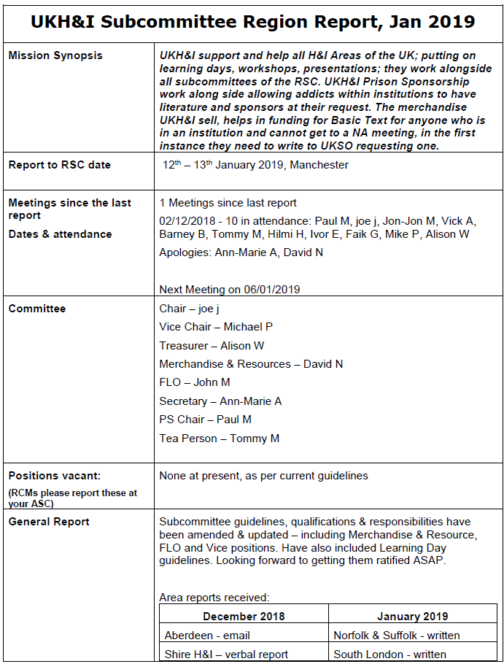
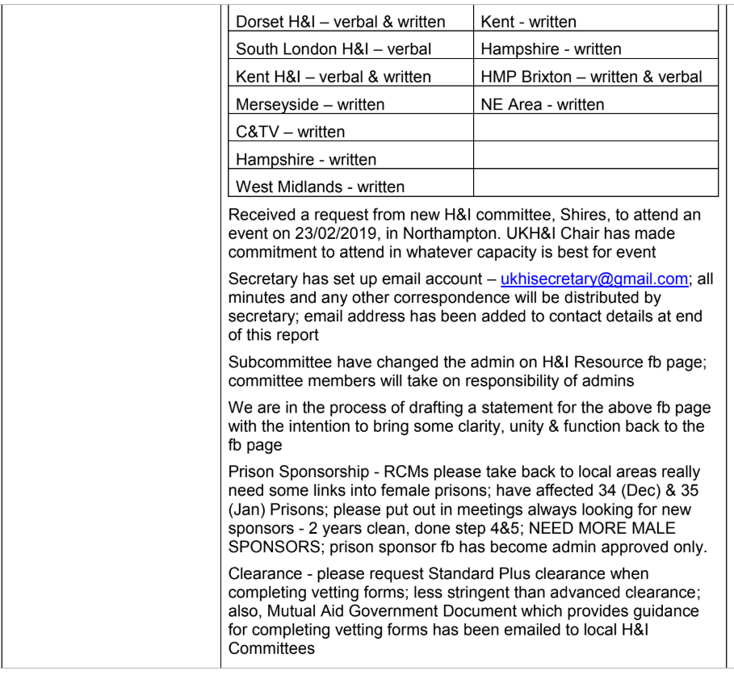
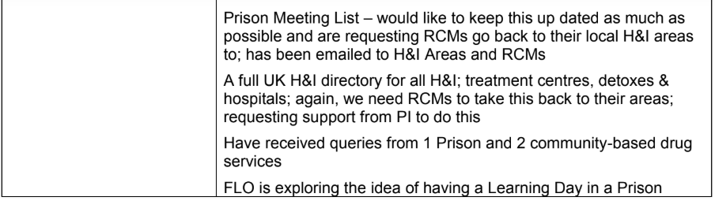
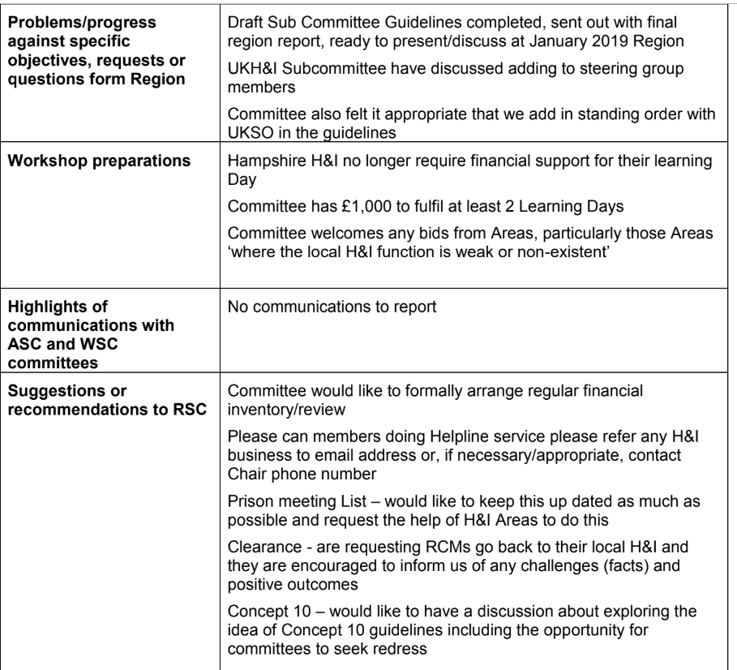
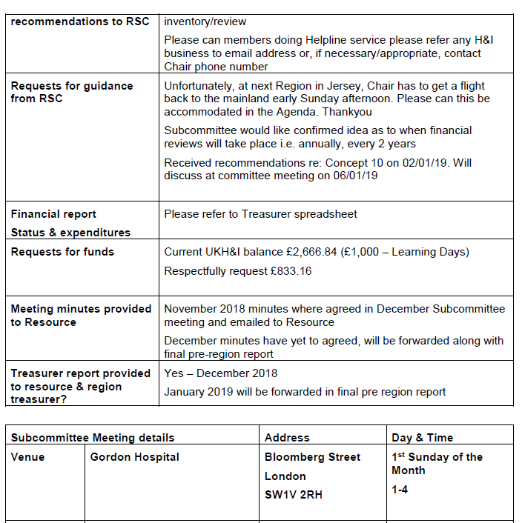

UKPI – Public Information

UKPI
Mission Synopsis: | To maximise the national profile of NA so that everyone in active  drug addiction knows about us (or knows someone professional who  knows about us).
Report to RSC date: | 12-13 January 2019 in Manchester
Meetings since the last report -Dates & attendance: | December 5th 2018 7pm Berkeley House, Berkeley Sq., London W1J 6BR. Attended by 6 committee members
Committee: | Massimo – Chair, Kevin – Treasurer [needs ratifying], Chris [Events], Ed [Media Rep] , Charlie [Fellowship Liaison Officer], Tom M [Social Media], Will B [Secretary] Tom B [Secretary
Positions vacant:  RCMs please report at ASC | Vice Chair, Vice Treasurer, Vice GLO
General report: | Draft UKPI guidelines for approval by Region are attached.  A draft copy of the leaflet proposed for distribution to the fellowship based on the survey of UK NA members completed on 31st August will be distributed at Region for comment and approval. .
Problems/progress against specific objectives, requests or questions from Region: | Approve our new draft UKPI guidelines. Approve Survey leaflet for distribution to the UK fellowship.
Workshop preparations: | We have arranged a training day in the north east for Sunday 20th January 2019. Also waiting to hear back from a couple of areas interested in setting a training day up.
Highlights communications w/ ASC & WSC committees: | We need assistance in obtaining up to date details from each ASC of their Area PI contacts [names/emails and numbers].
Suggestions or recommendations to RSC: | NOTE OUR COMMITTEE MEETING has CHANGED TO A WEDNESDAY – details below.
Requests guidance fm RSC:
Finance report: request for funds | Request £526.20 to top us up. Current balance £1123.80
Meeting minutes sent to Resource? | Yes emailed.
Treasurer report sent to resource& region treasurer? | Sent to Resource and Region Treasurer.

Subcommittee Meeting details: |  | Address: | Day and time:
Venue: | c/o Rowe Henderson | Berkeley House, Berkeley Square London W1J 6BR [Green Park nearest tube] | First Wednesday of even months at 7pm 6/2/19 Skype available

UKSO – Service Office
UK Service Office
Mission Synopsis: | We exist to provide support to the NA Fellowship in England, Scotland and Wales, primarily the supply of printed material. We are a limited company whose remit is to sell NA approved literature at a price that covers our operating costs and no more – we are mandated to not make a profit.
Report to RSC date: | 12th – 13th January 2019
Meetings since the last report -  Dates and attendance: | UKSO Board Meeting 8/12/18 (meeting of the directors)  UKSO Committee Meeting 19/12/18 (meeting of the directors, special workers, and attended by Simon (RD) and Craig (RCM Surrey, Vision Committee)
Committee: | Chair – Micky C  Vice Chair – Andy O  Operations – Alex A  Finance – Bonita  Secretary – Lucy C
Positions vacant:  (RCMs please report these at your ASC) | None
General report: | - Approved price rise of 5% to ensure service does not continue to operate at a loss. Increase in costs due to a price increase from NAWS (NA World Services, the organisation from whom we are obliged to purchase over 90% of our literature) and an increase in the cost of Euros (which, as we buy from NAWS in Belgium and pay for in Euros, means our costs have gone up).  - We have received some technical guidance from HMRC on action in the case of a no-deal Brexit which would mean we would need to pay customs duty and arrange our own imports. We have obtained an Economic Operator Registration & Identification (EORI) number but agreed we do not need an agent to facilitate imports as we deal with only one supplier (NAWS in Europe).  - We continue with application to Charities Commission as directed by the Commission.
Problems/progress against specific objectives, requests or questions from Region: | - We were asked to gather data on where groups are buying literature from, if not from UKSO. We asked the European office whether they could share this information with us and were told we would need to follow up with NAWS. We are awaiting a reply from NAWS. We can see from our own records that some areas appear to have reduced purchases from UKSO, but we can’t say whether they are buying from elsewhere or have simply reduced purchases overall.  - Charitable status. This is an application for Service Limited, the limited company, NOT for Region / UKNA / NA as a whole. The limited company was set up as a charity with charitable objectives but is not registered with the Charities Commission. We have been told that we should make the application, and let the Commission decide whether we are a charity. The benefit of charitable status would be a) possible exemption VAT on rent (at discretion of landlord) b) likely reduction / exemption from corporation tax c) cheaper software, charitable discounts on services d) 80% -100% discount on business rates.
Workshop preparations: | N/a
Highlights of communications with ASC and WSC committees: | Query about charitable status, whether this applied to NA as a whole or just the service office. Answer: just the service office.
Suggestions or recommendations to RSC: | None
Requests for guidance from RSC: | N/a
Financial report:  Status and expenditures  Request for funds | - Sales can be finalized as books now closed, overheads not yet final.  - Sales: 11,013 (up from budget 9,520). YTD: deficit of £8.5k. Last year £6.5k surplus, which was £20k when the business rates rebate of £13.5k is included.  - Will get corporation tax from last year rebated.
Meeting minutes provided to Resource? | Will be provided.
Treasurer report provided to resource and region treasurer? | Provided full figures to November 2018. Final year accounts will be submitted when complete.

UKW&H Website & Helpline
Helpsite Webline
Mission Synopsis: | The objective of this subcommittee is to fulfil NA’s primary purpose in accordance with the Fifth Tradition: “To carry the message to the addict who still suffers.” This is done in accordance with the 11th Tradition: “Our public relations policy is based on attraction rather than promotion; We need always maintain personal anonymity at the level of press, radio and films.” It is done by making information available to addicts and the public in a manner that is clear and easy to understand.
Report to RSC date: | January 2019
Meetings since the last report -  Dates and attendance: | November 2018 - 8 attendees  December 2018 – 5 attendees
Committee: | Andrew – Chair/Site Admin/Email Coordinator, Tania – Share Review Chair, Ben – Secretary, Rachel – Share Review Vice Chair, Julianne – Interim Treasurer, Steve – 12 Step Coordinator, Gav – Events Coordinator, Sam – Meetings Coordinator, Scott – Vice Meetings Coordinator, Ade – Distance Sponsorship Chair, Trudi – Online Meetings Coordinator, Sammy – Online Meetings Vice Coordinator
Positions vacant:  (RCMs please report these at your ASC) | Vice Chair, Distance Sponsorship Vice Chairs, Vice Treasurer, Vice Secretary, Email Coordinator, Helpline Volunteers, Helpline Day Coordinator, Helpline Trainers, Share Review Committee Reviewers, Distance Sponsors
General report: | We are in the process of reorganising our subcommittee to better reflect the diverse nature of our committee. The main change is that there will be 5 subcommittees underneath our main committee. This will help focus discussions.  Share Review: 27 shares reviewed (8 rejected) since the last Region. New Guidelines need to be ratified.  Website: With Kent ASC we have been testing out a file storage solution hosted by ourselves alongside a new webmail interface. If other ASCs are interested please let me know. There may be an increase in the cost to our server provider if we require extra storage on our server.  Distance Sponsorship: No report received. New guidelines brought that need to be ratified.  Helpline: All going well. Need volunteers as always. New committee meeting every 2 months.  New WhatsApp guidelines to be ratified.  Online Meetings: All going strong with an average attendance of 20-30. NYE Marathon meeting had 44 attendees.
Problems/progress against specific objectives, requests or questions from Region: | Update meeting contacts and running or shut of xmas and new year.  Need members for our committee especially vice chair.  Ratify DS & WhatsApp guidelines
Workshop preparations: | None
Highlights of communications with ASC and WSC committees: | Updated meetings list sent off to NAWS. DS has been attending NAWS Rural webinars.
Suggestions or recommendations to RSC: | Please help recruit 12 step volunteers and committee members.
Requests for guidance from RSC: | How to encourage people to serve on the committee i.e. as vice chair, treasurer and secretary?
Financial report:  Status and expenditures  Request for funds | Request full £2260 stipend
Meeting minutes provided to Resource? | Yes
Treasurer report provided to resource and region treasurer? | Yes

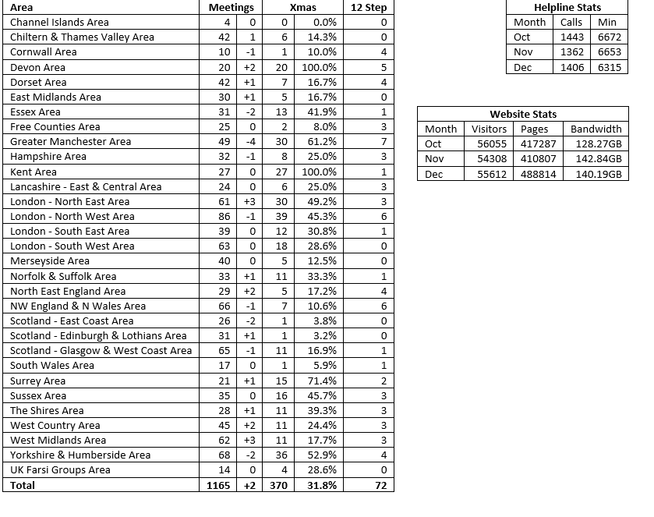

Ad Hoc – Inventory

UKRSC Inventory
The UK RSC sets time aside time each year for conducting an RSC inventory, for much the same reason as NA members conduct personal inventories: to stop, consider their actions and attitudes and redirect themselves to their ideals.
Objectives - The objectives of the inventory are as follows:
  - To invite feedback and suggestions from ASCs and groups.
  - To highlight Regions achievements.
  - To identify opportunities for improvement at the RSC.
  - To prioritise regional services to better align with ASCs’ and groups’ needs.
Questions
- Do we meet in an orderly and timely fashion staying focused on our services? Do we adhere to the 12 traditions, 12 concepts of NA and the UKRSC guidelines in all our decisions and actions?

- Do we welcome our new trusted servants and provide all necessary information and support? Is training in service adequate?

- Do we maintain an atmosphere of courtesy and mutual respect in our RSC and do we protect the right of free debate or do we allow our members to be intimidated or manipulated?

- Do we encourage our members to make known their needs, concerns and requests? And do we allow time listen to the minority point of view?

- Should we change the order of the RSC agenda? Should we read reports in full or only important information and questions?

- Are we responsive to the needs of NA groups in our region? How can we make doing service at region attractive to our members?

- How can we improve communication and information between the groups, ASCs and other service committees?

- Do we allow ourselves time to make decisions or do we sometimes rush the decision making process?

- Are we responsible for our decisions concerning the management of fellowship funds?

- Do we maintain records of our decisions and actions making them fully available to the NA members we serve?

- Does the body owe any amends?

- What three words best describe regional service?

Split into groups for 40mins to answers. The come back together and 40mins giving the answers. Last 40mins to come up with recommendations.

Ad Hoc – visionUKSO
Vision UKSO Ad-hoc subcommittee.
Mission Synopsis: | Motion: To form an ad-hoc committee with the purpose of a feasibility study regarding location, function and future of UK service office.
Mission Synopsis: | Intent: To have an accountable body that has the time needed to explore this in depth.
Mission Synopsis: | Resource implications: (financial and/or human): None to start. Initial meetings would be held via Skype and research can be done online.
Report to RSC date: | January 2019
Meetings since the last report -  Dates and attendance: | We have met as a committee four times so far, the latest meeting being Sunday 30th December 2018
Committee: | Micky C, Martina S, Craig SK, Lisa N, Bonita, Tracey J and Vivek C
Positions vacant:
(RCMs please report these at your ASC)
General report: | Following the feedback from the November 2018 RSC these are now the four options we are working with as a committee.  - UKSO moves to a new location providing the same services as it does now.  - UKSO moves to a new location, with meeting space for UK subcommittees, Region and Archiving  - Close the UKSO and use the European Service Office in Brussels.  - UKSO to remain in its current location.  AA General Service Office in York  On the 18th December we visited the AA General Service Office in York  Attending were: Craig SK, Tracey J, Vivek C, Lisa N and Mickey C.  Attached from our visit is:  - The Q&A from our visit  - The AA GB General Report 2017  We had a very thought-provoking exchange and our takeaways were:  - UKSO funding. Can we use a different funding model so that our cost savings remain sustainable long term? The AA GSO’s funding breakdown is as follows:  38 % from the sale of Literature, 54 % from Contributions from Conference and 8% from other sources (please see attached AA Report)  The AA Big Book is £8 incl p&p and has remained at this price for 10 years.  - We should be seeking Charitable status. Main reason is a 43% reduction is in VAT but also because of the kudos that comes with being a charity. You are not seen as a profit-making enterprise. As a charity you are held to much higher standards and have to be fully transparent.  - We need a 5 to 10-year plan to help UKSO move forward in incremental steps rather than one giant leap.  Location  Due to lack of feedback from the Areas we are taking a proactive approach and are currently costing out the following locations:  Greater London, Birmingham, Manchester, Preston, Wakefield & Coventry  We are mindful that we need to start moving this process forward so that we are in a position to give this body an informed set of choices in January 2020, however we are still open to suggestions from Areas should they be forth coming.  We would also like to request costs from the subcommittees for the rental of their venues per annum:  UK H&I, UK PI, RSC, Website / Helpline, UKCNA and Archiving services  Deadline  Deadline for Region to decide will be January 2020. This is to give UKSO enough time to implement contracts / recruitment etc before they have to give notice in June 2020.
Problems/progress against specific objectives, requests or questions from Region:

Workshop preparations: | None
Highlights of communications with ASC and WSC committees: | None
Suggestions or recommendations to RSC: | None
Requests for guidance from RSC: | None
Financial report:  Status and expenditures  Request for funds | As region approved our expenses for the visit to York, I am submitting £177 for reimbursement.
Meeting minutes provided to Resource? | Resource is a member of the vision.ukso@ukna.org and so gets a copy of our meeting decisions and action points after every meeting.
Treasurer report provided to resource and region treasurer? | None

Concept 10 AD HOC
Concept 10
Mission Synopsis: | As outlined in the UK RSC Concept 10 Guidelines
Report to RSC date: | January 2019
Meetings since the last report -  Dates and attendance: | We have met every Monday since the November 2018 RSC
Committee: | Craig SK – RCM Surrey, Brian K – RCM The Shires, Simon UK RD, Natalino ret RCM Dorset & Matt ret UK ALT RD
Positions vacant:  (RCMs please report these at your ASC) | N/A
General report: | Since the November UK RSC we have done the following:  - Contacted all parties involved and their consent to be a part of this C10 process.  - We have communicated with those individuals seeking redress through this Concept 10 procedure and have Identified the harm caused to them and the redress they are seeking.  - We have communicated with the person named in the Concept 10 and discussed a suitable redress.  - This redress has been communicated with those individuals seeking redress through this Concept 10 procedure and we are awaiting their acceptance / refusal. Deadline for this is the 7th January.
Problems/progress against specific objectives, requests or questions from Region: | Our reasons for dealing with the process by email/in writing rather than by phone or face to face is for transparency, to avoid misinterpretation, the prudent use of NA funds and geography (as a committee we are spread across the UK as are those involved in this concept 10 process).
Workshop preparations: | N/A
Highlights of communications with ASC and WSC committees:
Suggestions or recommendations to RSC: | From all the responses we received our group conscience is to suggest the following as a way forward:  - Ask A to post an apology on to the same Facebook Group as the original post  ii. Ask A to make a written apology that will be read out at Region
Requests for guidance from RSC: | We are experiencing the following issues with this C10 process:  - We have found there to be a lack of experience in successfully dealing with concept 10s that we were able to draw on, particularly in relation to a committee presenting a C10 and using the process outlined in UKNA RSC guidelines  - The UK RSC guidelines outlines a process specifically for those individuals seeking personal redress. They are not a mechanism for a committee seeking redress and they do not allow for a spokesperson or proxy.  - As a committee we have reach a consensus on what amends to recommend and this was communicated to all parties.  - The individuals involved opted to respond to us via a proxy, in this case the chair of UK H&I. As a result, we are unable to reach a consensus on how to move forward with this C10.  What would the RCMs like to do?
Financial report:
Status and expenditures
Request for funds
Meeting minutes provided to Resource?
Treasurer report provided to resource and region treasurer?

